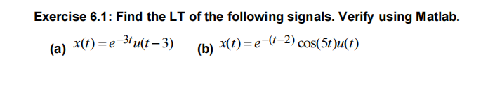
Sol: syms t s
% (a)
x1 = exp(-3*t)*heaviside(t-3);
X1 = laplace(x1, t, s);
% (b)
x2 = exp(-(t-2))*cos(5*t)*heaviside(t);
X2 = laplace(x2, t, s);
% Plot both time-domain signals for t = 0..10
fplot(x1, [0 10]); hold on;
fplot(x2, [0 10]);
legend('x_1(t)', 'x_2(t)'); grid on;
title('Time-Domain Signals');
disp('Laplace of (a):'); disp(X1);
disp('Laplace of (b):'); disp(X2);
Figure:
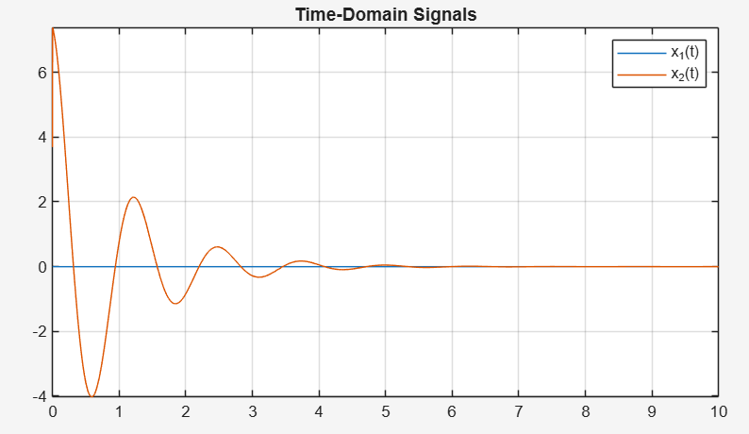
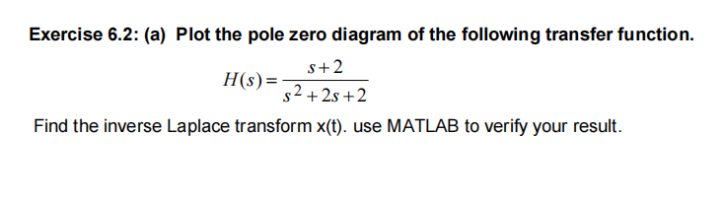
Sol: syms s t
H = (s+2)/(s^2 + 2*s + 2);
% Pole-zero plot
pzmap(tf([1 2], [1 2 2]))
% Inverse Laplace
x = ilaplace(H, s, t)
% Plot x(t) for t>=0
fplot(x, [0 10]); grid on;
title('x(t)'); xlabel('t'); ylabel('x(t)');

figure:
